Entry to Year 9
English Examination 2017

Time allowed – 1 hour
There are two sections in this paper.
Please ensure you allow sufficient time to complete both sections.

Section A Reading – Time Allowed 30 Minutes
Section B Writing – Time Allowed 30 Minutes

Write your answers on the lined sheets of
paper provided

PLEASE WRITE YOUR FIRST NAME AND FAMILY NAME (SURNAME) IN BLOCK CAPITAL LETTERS
AT THE TOP OF EVERY SHEET

SECTION A READING

Spend 30 minutes on this section

Read the following extract and then answer the question which follows.
The extract is from a short story called ‘Sync’ by Suzannah Dunn. (You may annotate this copy if you wish to help you with your response to the question.) In this part of the story, the writer describes the atmosphere of a long journey at night.

For hours, the moon has been rolling around the windows of this minibus like a pin-ball. And now we are passing roofs which are slick with moonshine. These roofs are new to our journey: for hours we were on a motorway, in the middle of nowhere, overtaken by vehicles with unblinking yellow eyes and snappy indicators. In the headlamp-slashed darkness, my friends’ faces were dilated to pitch and catch conversation over the noise of the engine, the rolling of the tyres. For a while, now, though, everyone has been quiet; even Mr Stanford, whose busy eyes, in his high, narrow mirror, have become smaller and more level. The only other open eyes are those of the only other boy on this field trip, Lawrence; the view from one of the windows licks through the shiny surface of them. With the appearance of the roofs, I realize that we are nearly there, and my heart sinks. What is it that they say, in planes? We are commencing our descent.

Hours and hours of engine vibration have drummed my thighs into the wooden slats of the bench, but I am further pinned down by Rachel, who is slumped asleep on me. A hairsprayed sprig of her hair lisps into my ear with every bump and turn of the minibus. One of her hands has dropped between her thigh and mine, and lies on both, open. On the tops of her upwardly-curled fingers, the thin crescent moons of her nails are oddly shadowed: she has painted them, because we are away from school, where nail polish is forbidden. Mr Stanford brakes, pauses behind a badly-parked car for a chain of oncoming traffic to pass; Rachel presses harder onto my shoulder, sinks further. There has been a lot of this, the stopping and sinking, like a drunken dance, since we turned from the motorway into these towns of crowded chip shops and dark banks, towns so much smaller than our own. An empty can growls again on the floor. I cannot reach with my feet to stop it. Lawrence’s eyes peel from the window and follow the can, they are wide with worry, but he makes no move, his hands in prayer between his thighs.

In the extract from ‘Sync’, how does the writer create a tense atmosphere and a vivid setting? Answer as fully as you can and try to write about a page. Please use quotations to back up your points.

You may want to consider the following points:
- What kind of environment is being described
- The descriptive language used and its effect
- Details of the journey and what they suggest
- Any change in atmosphere
(20 marks)

SECTION B WRITING

Spend 30 minutes on this section
Look at the picture below and then write a description, or the beginning of a story based on it. Aim to make your writing as interesting as possible, using descriptive techniques to make it vivid. Try to write as accurately as possible.

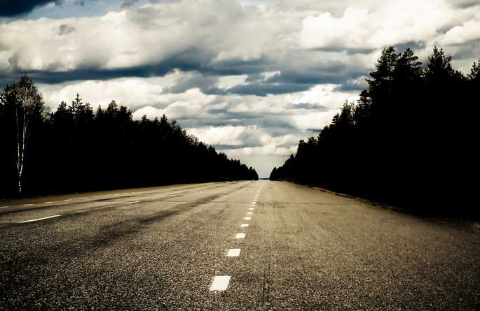

20 marks

YOUR NAME

Your first name ……………………………………………………………………………………………….………………….

Your family name (surname) …………………………………..……………………………………….…….……………..

PLEASE WRITE YOUR NAME IN BLOCK CAPITAL LETTERS

MATHEMATICS ENTRANCE EXAMINATION
ENTRY TO YEAR 9

Time Allowed : 60 minutes

Instructions to candidates

Write your name at the top of this paper and on any other paper that you use.
Answer all questions in the spaces provided in this question paper.
Show all steps in any calculation and state the units.

1.
(a) Simplify $x^{7}×x^{4}$

…………………………………….( 1 mark )
(b) Simplify $\frac{({x^{3})}^{5}}{x^{4}}$

…………………………………......( 2 marks )
( Total for question = 3 marks )
2.
(a) Work out 63% of £742

……………………………………………….( 2 marks )
(b) The price of a jigsaw increased from £2.60 to £3.77
Find the percentage increase.

………………………………………………..( 2 marks )
( Total for question = 4 marks )

3. Here is a sequence of patterns made from squares
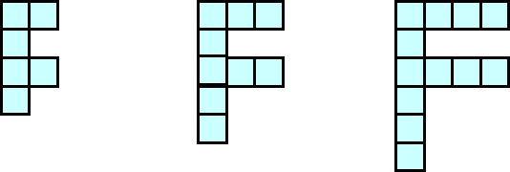
Pattern 1 Pattern 2 Pattern 3
(a) Draw the next pattern in this sequence

Pattern 4 ( 1 mark )
(b) Find an expression, in terms of n, for the total number of squares in pattern number n

…………………………………………………..( 2 marks )
(c) A pattern in this sequence is formed from 96 squares.
Work out the pattern number of this pattern.

………………………………………………….( 2 marks )
( Total for question = 5 marks )
4. Not drawn to scale
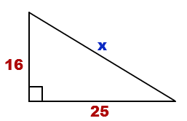
(a) The diagram shows a right-angled triangle with two sides of length 16 and 25, as indicated.
Calculate the length marked x on the diagram.
Give your answer to 3 significant figures

…………………………………………..(3 marks )
(b) A triangle has sides of length 8.4 cm, 6.3 cm and 11.5cm.
Is this triangle a right-angled triangle? Circle YES or NO
(YOU MUST SHOW RELEVANT CALCULATIONS TO EXPLAIN YOUR ANSWER)

(2 marks )
( Total for question = 5 marks )
5.
(a) Simplify $9y ×8y$
………………………………………..( 1 mark )
(b) Expand $7(2h-3)$

……………………………………….( 1 mark )
(c) Factorise $6f-9$

………………………………………( 2 marks )
(d) C = 3a² – 6ab
If a = 4 and b = 5 , find the value of C

……………………………………..( 2 marks )
( Total for question = 6 marks )
6.
(a) A circle has a radius of 5cm. Find the circumference and the area.

Circumference……………………………………..
Area……………………………………..
( 3 marks )
(b) Show that $4\frac{1}{3} ÷ \frac{5}{6}=5\frac{1}{5}$

( 3 marks )
( Total for question = 6 marks )

7.
(a) Factorise $20y^{2 }-8y^{3}$

…………………………………………………..( 2 marks )

(b) Expand and simplify $( x+7 )( 3x+6 )$

…………………………………………………..( 2 marks )
(c) Expand ${( x-5 )}^{2}$

…………………………………………………( 2 marks )
( Total for question = 6 marks )
8.
Here is a fair spinner
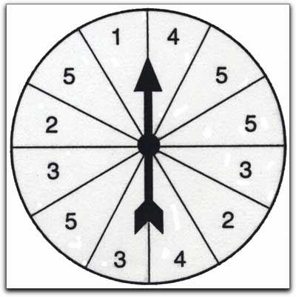
The spinner is split up into twelve equal sectors, numbered as shown.
Elizabeth spins the spinner once
(a) Write down the probability that the pointer will land in a sector labelled with the number 5

……………………………………….( 1 mark )
Philip spins the spinner 180 times
(b) How many times would you expect the arrow to land in a sector labelled 4 ?

……………………………………..( 2 marks )
( Total for question = 3 marks )

9.
(a) Showing clear algebraic working, solve the equation $8x+11=67$

$x=$………………………………( 2 marks )

(b) Showing clear algebraic working, solve $5(2x-3)=6-5x$

$x=$………………………………( 3 marks )
( Total for question = 5 marks)

10.
(a) Venus and Serena split their winnings from a tennis tournament
in the ratio $17 :11$
If Venus gets £535,500 , how much does Serena get?

£ ……………………………( 2 marks )
(b) Put these in order from smallest to largest.
66% $\frac{13}{20}$ 0.7 $\frac{2}{3}$ $\frac{15}{23}$

……………………………………………………………………………………………………………………(2 marks )
( Total for question = 4 marks )

11.
The area of a trapezium is given by this formula
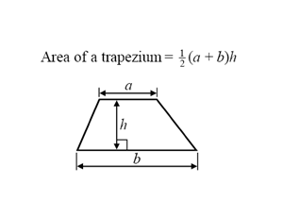
Calculate the area of this trapezium
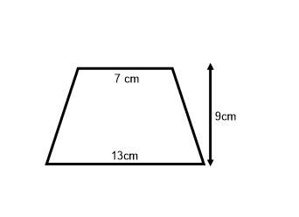

………………………………………………………………………cm²
(Total for question = 2 marks)

12.
(a) Solve the inequality $5x+12≥-8$

………………………………….(2 mark)

(b) Write down the inequality illustrated on this number line.
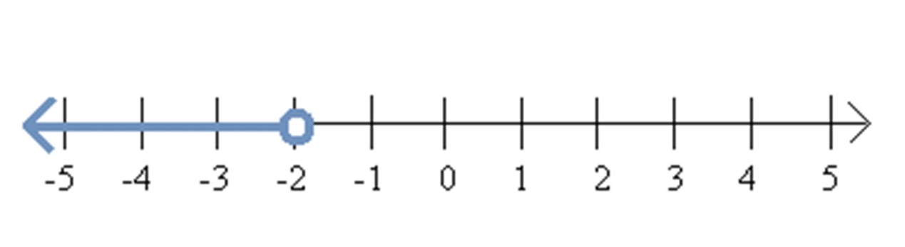
……………………………..(2 marks)
(Total for question = 4 marks)
13.
(a) Below is a list of the marks which 10 pupils scored in a test.
17 24 6 8 19 17 19 7 20 17
(i) Write down the modal mark for the class
…………………………………(1 mark)
(ii) Work out the median mark for the class

………………………………...........(2 marks)
(b) In a different test, the marks of 30 students were as shown in the frequency table below
MARK | NUMBER OF STUDENTS
14 | 4
15 | 6
16 | 5
17 | 3
18 | 2
19 | 7
20 | 3

Calculate the mean mark for the group

………………………………………………………….(4 marks)
(Total for question = 7 marks)

END OF PAPER – Check through your answers, carefully. Total Mark 60

